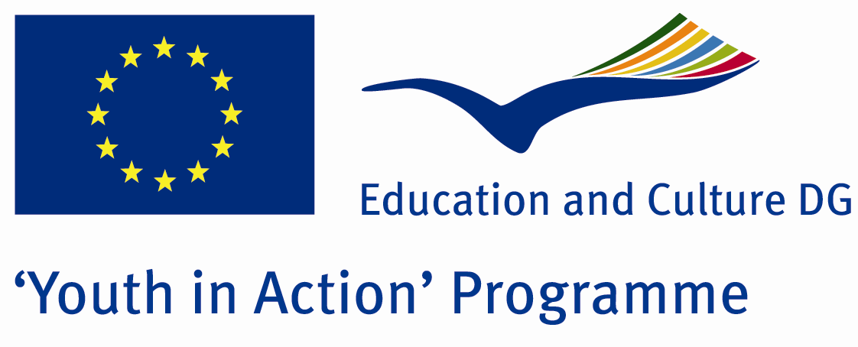

The People Who Like Red



ACTION 1.1 – Youth Exchange

17-24th August, 2011

Duzce/TURKEY

ACTION 1.1 Youth Exchange
17-24th August, 2011
Duzce, TURKEY

Please contact directly to;
adventurerpeacepigeons@gmail.com

Project Summary;
Some people said they are gipsy... Some people said they are thieves. Ones said they are bad people… We claim that most of them are so kind and friendly people. Yes, i mean that Romens people… Do you know how difficult is to be Romen in this world. You have been lived in a country for years… But you can’t feel you belong to this country… Because the other people doesn’t allow this… In all the world, most of the people see you as witch… But the worst thing is not your fault… Just only You were born from Romen mother… And you didn’t choose her… And moreover she is the best mother for you… But some people think that you are second class person because of only your relatives, your father, mother or family…
To sum up, in this Project we learn romen’s culture, lives and musical skills. Because most of them are true-born musicians… It is the miracle of God. At the end of the Project, the participants will learn it is so bad that to evaluate people as the bad people without knowing anything about them. For this aim, for learning their culture, dances, music, for fun and to be friend from the other countries, participate us.

Project Title; The People Who Like Red

Date and Venue ; 17-24th August, 2011 Duzce/TURKEY

Target Group; Non profit/non governmental organization, Public body, Body active at European level in the field of youth (ENGO), Informal group of young people, e.t.c…

Participants; 5 people from each country (18 - 25). Totally 8 countries.

Conditions; Accommodation, board and programme costs will be financed through European Commission Youth in Action Programme (Action 1.1). Travel costs will be reimbursed in 70% (APEX Tarrifs). Organizations from all 27 EU member countries plus Liechtenstein , Norway and Iceland are eligible to take part.

Working language; English

Organizer; Adventurer Peace Pigeons

How to apply: If you are interested, please send your Part III forms to
0090 216 483 21 67 by FAX please. (Fulfilled Part III which you can find in the attachment, of course signed and stamped) ..

Note: jpeg is not allowed..please send by fax…

Next step 2;
Original send via regular post to this address please:

Ertan DERİN
Öner İnşaat
Abdulhalik Renda Cd.
Parlar Sk. No:4 Pendik/İSTANBUL

If you have any questions you may contact with: adventurerpeacepigeons@gmail.com

Deadline for application; until 20th January 2011.

For Further information:
Contact Person
Ertan DERİN
Öner İnşaat
Abdulhalik Renda Cd.
Parlar Sk. No:4 Pendik/İSTANBUL

e-mail : adventurerpeacepigeons@gmail.com
Mobile : 0090 542 393 93 90
Fax : 0090 216 483 21 67

